**LOW ORBIT ION CANNON (LOIC) ON KALI**

**Low Orbit Ion Cannon** (**LOIC**) is an open source network stress testing and denial-of-service attack application, written in C#. LOIC was initially developed by Praetox Technologies, but was later released into the public domain,and now is hosted on several open source platforms.

The official version and project page can be found here: <http://sourceforge.net/projects/loic/>

Using LOIC for any illegal activities could lead to criminal prosecution. This blog is for education purposes.

LOIC has been used in the past by attackers that have been found guilty of computer crimes.

**DISCLAIMER:** USE ON YOUR OWN RISK. THIS SOFTWARE IS PROVIDED BY THE COPYRIGHT HOLDER OR CONTRIBUTORS “AS IS” AND ANY EXPRESS OR IMPLIED WARRANTIES, INCLUDING, BUT NOT LIMITED TO, THE IMPLIED WARRANTIES OF MERCHANTABILITY AND FITNESS FOR A PARTICULAR PURPOSE ARE DISCLAIMED. IN NO EVENT SHALL THE COPYRIGHT HOLDER OR, THIS SITE, OR CONTRIBUTORS BE LIABLE FOR ANY DIRECT, INDIRECT, INCIDENTAL, SPECIAL, EXEMPLARY, OR CONSEQUENTIAL DAMAGES.

1) update kali linux

**apt-get update apt-get upgrade**

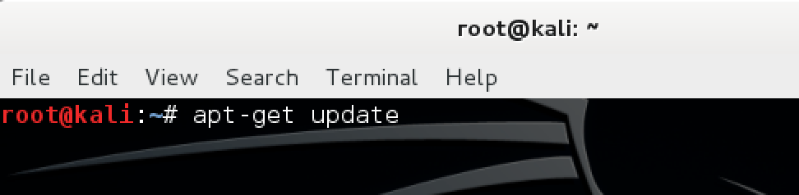

2) install development tools

**apt-get install git-core monodevelop**

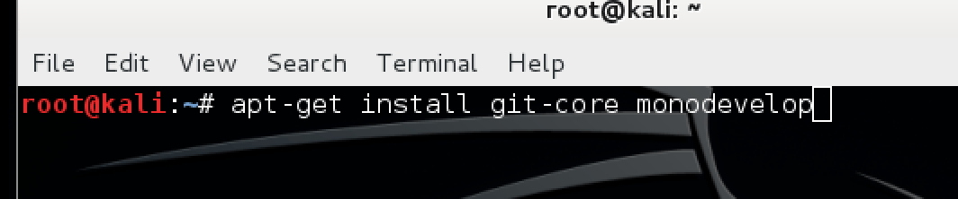

2) Make a directory to download and store low orbit ion cannon

**mkdir loic**

3) Change into that directory

**cd loic**

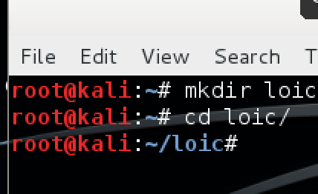

4) Download loic from <https://www.hightail.com/download/UlRRNHAySys1bmhFQmRVag>

5) change permissions on script

**chmod a+x loic.sh**

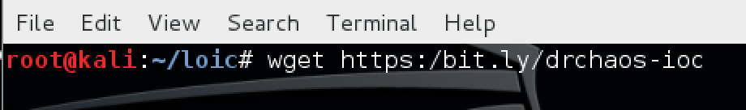

6) install

**./loic.sh install**

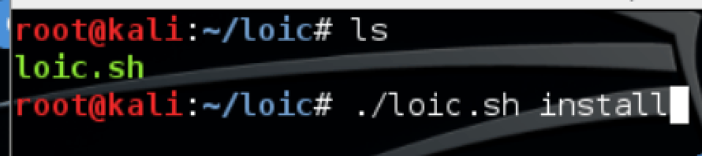

7) update

**./loic.sh update**

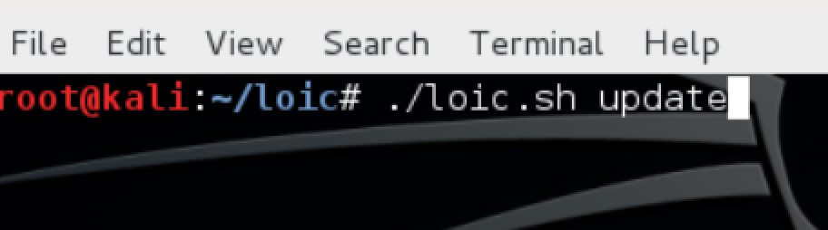

8) run

**./loic.sh run**

